**Installation**

Option 1: Install from Eclipse Marketplace (Easier, straightforward)

1. Help -> Eclipse Marketplace

2. Type “EclEmma” in the search box

3. If you didn’t install before, then press install button to install EclEmma, and restart Eclipse afterward. Else, you are all set and ready for testing.

Option 2: Manually install

1. Download a version of EclEmma zip file from the following website: <http://www.eclemma.org/download.html>

2. Unzip the archive into dropins folder of your Eclipse installation, then restart Eclipse

**User Guide**

After one of the above installation, you should be able to see the EclEmma coverage button in the toolbar as following:

Launching Toolbar

The most important button out of the toolbar is the one mark in the red box as below:

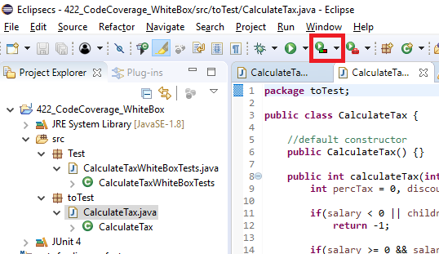

**Example**

Here is an example class CalculateTax. Inside the class there is a function/method having salary and children pass in as parameters.

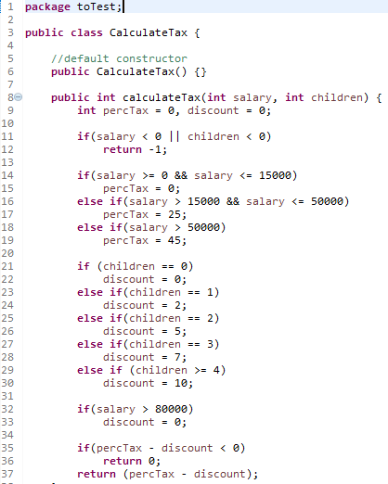

And the following is the test cases

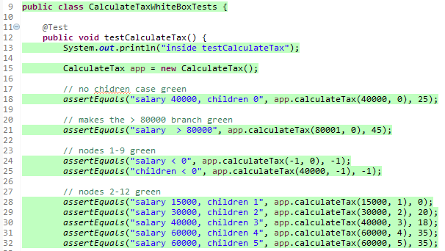

While you have your files open up, just simply press the button  to test for the coverage. After finish loading, an additional block should appear on the bottom of Eclipse like below:

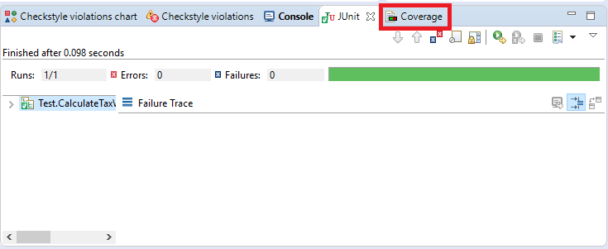

Tap on “Coverage”. The Coverage column is the total coverage out of the entire package, and if you want to check on each individual class/function/method’s coverage, click on the arrow mark as below, until you get to the part you want to review:

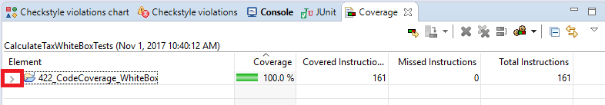

Now you know all the coverage over the entire package with EclEmma.

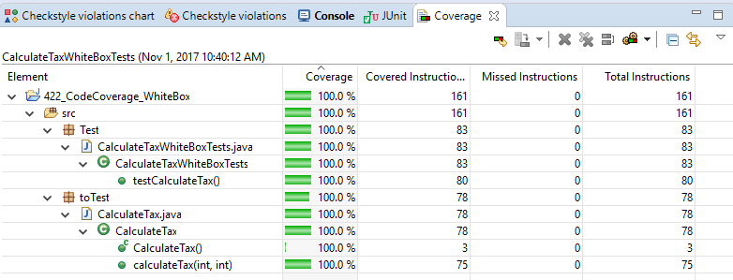

**Q: What to do if the coverage is not 100%?**

There are more information can be helpful on the java page itself. Now when you get to the java file page, you realize the lines are either red/ yellow/ green. The meaning of each coloring as below:

**red** - The line is not coverage base on the test you wrote

**yellow** - There are path you didn’t not cover in you test

**green** - This path is being cover

When your mouse hover on the green diamond shape, it will notice you all the branches are cover and the line will appear in green.

When your mouse hover on the yellow diamond shape, it will notice you have how many branches you are missing on coverage, and the line will appear in yellow.

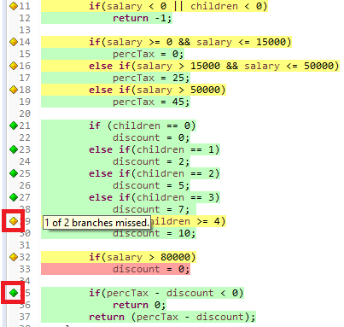

**Q: How to export result into different type?**

For user to export test result into different type, we will have to first run the test as shown in the example, then right click on your mouse on the coverage result panel like below:

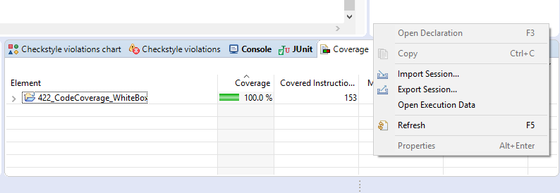

There will be different options to choose from, but what we want is to click on “Export Session…”, and a popup window will show up as below:

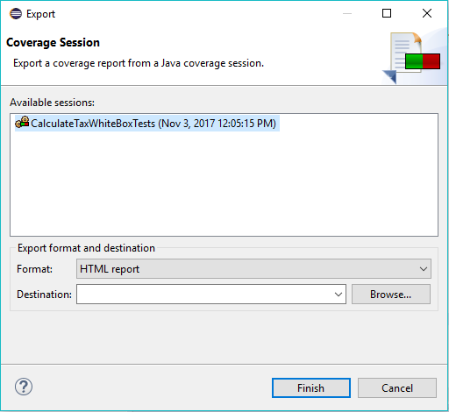

The “Format” drop down menu have different type of report you can choose from.

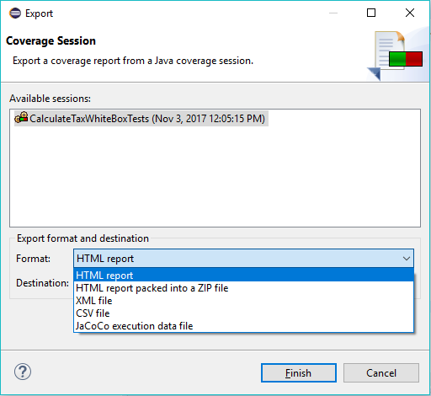

Pick the type of report you are looking for, then choose the “Destination” you want the file be save at, and then press the “Finish” button, and the file you request for will appear. Now you will have the type of file you requested and waiting to be review at the Destination location you choose from.

**Be Aware**

- Powermock and EclEmma do not goes well together, and whenever they comes together, the return coverage always show 0%.

This is a known issue according to internet, and here is some of the discussion on github and stackoverflow about this issue:

<https://github.com/powermock/powermock/issues/422>

<https://github.com/jacoco/eclemma/issues/15>

<https://stackoverflow.com/questions/23363212/powermock-eclemma-coverage-issue>

- Understanding every plugin have their own limitation is important. In this case some suggests using eCobertura. It is basically same as EclEmma, but it will not have the same problem with the coverage display. However, this plugin also has their own limitation, where once the test is run, the color marker will never goes away.

Here is the discussion on bitbucket:

<https://bitbucket.org/jmhofer/ecobertura/issues/6/cant-find-a-way-removing-ecobertura>

One of the solution:

<https://github.com/jmhofer/eCobertura/issues/8#issuecomment-431087>

Official eCobertura websit:

<http://ecobertura.johoop.de/>

**Tips**

- Normally if statement can only cover 1 branch, for complete with all branch you will need extra else if statement and else statement to make the yellow lines turn into green.

- Fix and try to hit all cases. Fix it all one case by one case. Be patient and at the end you will be able to get 100% coverage.